Chapter 11, Problem 8.

In the circuit of Fig. 11.40, determine the average power absorbed by the 40-Ω resistor.

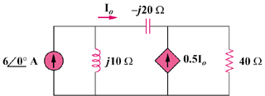

Figure 11.40
For Prob. 11.8.

